Design a small campus with 2 buildings connected by routers running OSPF. Create VLANs for Students and Staff at each building. Configure DHCP servers. Setup a DNS server. Practice subnetting to allocate IP addresses efficiently. Test with ping and traceroute.

Objectives
- To design and implement a small campus network with two buildings connected by routers running OSPF dynamic routing protocol.
- To configure VLANs for Students and Staff in each building, set up DHCP servers for automatic IP assignment, and configure a DNS server for name resolution.
- To practice subnetting for efficient IP address allocation and verify full network connectivity using ping and traceroute commands.
Theory
1. VLAN (Virtual Local Area Network)
Definition: A VLAN is a logical grouping of devices on a network, separated at Layer 2, regardless of their physical location.
Operation: Switches tag frames with a VLAN ID using IEEE 802.1Q. Access ports carry traffic for a single VLAN; trunk ports carry multiple VLANs simultaneously between switches and routers.
Application: Used to separate Students and Staff into different broadcast domains within each building for security and traffic management.
2. OSPF (Open Shortest Path First)
Definition: OSPF is a link-state dynamic routing protocol that automatically discovers and shares routing information between routers.
Operation: Routers exchange Link State Advertisements (LSAs) to build a complete map of the network. Each router calculates the shortest path using Dijkstra's algorithm. Neighbor state FULL means routing tables have been fully exchanged.
Application: Used to allow Router-A and Router-B to automatically learn each other's networks without static routes.
3. DHCP (Dynamic Host Configuration Protocol)
Definition: DHCP automatically assigns IP addresses, subnet masks, default gateways, and DNS server IPs to devices on a network.
Operation: A client broadcasts a DHCP Discover message. The server responds with an Offer, the client sends a Request, and the server sends an Acknowledgment (DORA process). The ip helper-address command on the router forwards DHCP broadcasts across VLAN boundaries.
Application: Used so all 6 PCs across 4 VLANs receive correct IP configuration automatically without manual setup.
4. DNS (Domain Name System)
Definition: DNS translates human-readable domain names into IP addresses.
Operation: A client sends a query for a domain name (e.g., campus.local) to the configured DNS server. The server looks up its A records and returns the corresponding IP address.
Application: Configured so devices can reach network resources using names like campus.local and buildingB.local instead of IP addresses.
5. Subnetting
Definition: Subnetting divides a larger IP network into smaller, more efficient sub-networks.
Operation: By adjusting the subnet mask, available host bits are used to create separate address spaces. A /26 mask provides 62 usable hosts; /27 provides 30; /30 provides 2.
Application: Applied to allocate appropriately sized subnets — larger /26 for Student VLANs and smaller /27 for Staff VLANs.
Network Topology
The campus network consists of two buildings, each containing one ISR4331 router, one 2960-24TT switch, one server, two student PCs, and one staff PC — 10 devices in total. Router-A and Router-B are connected via a crossover WAN link (10.0.0.0/30). Within each building, the router connects to the switch via a trunk link (Gig0/1) carrying both VLANs. Server-DHCP-DNS in Building A serves both DHCP and DNS for the entire network. Server-DHCP-B in Building B handles DHCP for its local VLANs.

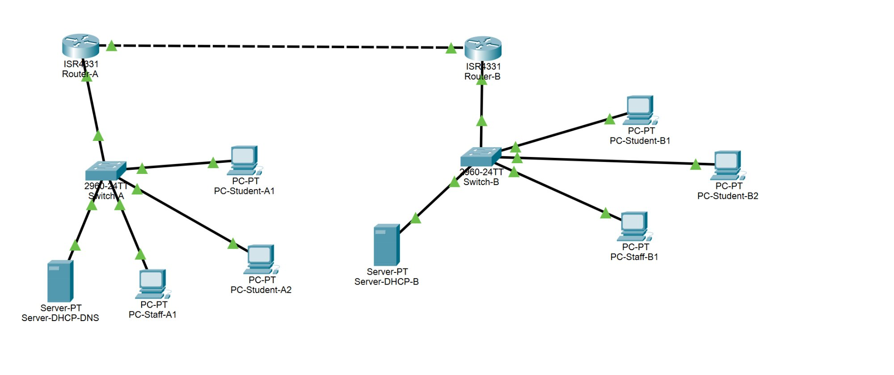
Figure 1: Campus Network Topology in Cisco Packet Tracer (all green links = active)
IP Addressing Scheme
Device | Interface | IP Address | Subnet Mask | Gateway | VLAN / Role
Router-A | Gig0/0/0 | 10.0.0.1 | 255.255.255.252 | — | WAN
Router-A | Gig0/0/1.10 | 192.168.10.1 | 255.255.255.192 | — | VLAN 10 GW
Router-A | Gig0/0/1.20 | 192.168.20.1 | 255.255.255.224 | — | VLAN 20 GW
Router-B | Gig0/0/0 | 10.0.0.2 | 255.255.255.252 | — | WAN
Router-B | Gig0/0/1.30 | 192.168.30.1 | 255.255.255.192 | — | VLAN 30 GW
Router-B | Gig0/0/1.40 | 192.168.40.1 | 255.255.255.224 | — | VLAN 40 GW
Server-DHCP-DNS | Fa0 | 192.168.10.10 | 255.255.255.192 | 192.168.10.1 | DHCP+DNS
Server-DHCP-B | Fa0 | 192.168.30.10 | 255.255.255.192 | 192.168.30.1 | DHCP
PC-Student-A1 | Fa0 | 192.168.10.20 | 255.255.255.192 | 192.168.10.1 | VLAN 10
PC-Student-A2 | Fa0 | 192.168.10.21 | 255.255.255.192 | 192.168.10.1 | VLAN 10
PC-Staff-A1 | Fa0 | 192.168.20.21 | 255.255.255.224 | 192.168.20.1 | VLAN 20
PC-Student-B1 | Fa0 | 192.168.30.20 | 255.255.255.192 | 192.168.30.1 | VLAN 30
PC-Student-B2 | Fa0 | 192.168.30.21 | 255.255.255.192 | 192.168.30.1 | VLAN 30
PC-Staff-B1 | Fa0 | 192.168.40.20 | 255.255.255.224 | 192.168.40.1 | VLAN 40

Note: PC IPs assigned via DHCP starting from .20. Servers and router interfaces use static IPs.

Configuration / Procedure
Step 1: Device Placement and Cabling
- Opened Cisco Packet Tracer and placed 2x ISR4331 routers, 2x 2960-24TT switches, 2x Server-PT, and 6x PC-PT devices on the canvas.
- Connected each switch to its router using Copper Straight-Through cable (Switch Gig0/1 to Router Gig0/0/1).
- Connected Router-A to Router-B using Copper Cross-Over cable (Gig0/0/0 on both).
- Connected all PCs and servers to their building's switch using Copper Straight-Through cables.
Step 2: VLAN Configuration — Switch A
Created VLAN 10 (Students-A) and VLAN 20 (Staff-A). Assigned Fa0/1-Fa0/3 to VLAN 10, Fa0/4 to VLAN 20, and set Gig0/1 as trunk.

Switch> enable
Switch# configure terminal
Switch(config)# vlan 10
Switch(config-vlan)# name Students-A
Switch(config-vlan)# exit
Switch(config)# vlan 20
Switch(config-vlan)# name Staff-A
Switch(config-vlan)# exit

Switch(config)# interface fastEthernet 0/1
Switch(config-if)# switchport mode access
Switch(config-if)# switchport access vlan 10 ! Server-DHCP-DNS
Switch(config)# interface fastEthernet 0/2
Switch(config-if)# switchport access vlan 10 ! PC-Student-A1
Switch(config)# interface fastEthernet 0/3
Switch(config-if)# switchport access vlan 10 ! PC-Student-A2
Switch(config)# interface fastEthernet 0/4
Switch(config-if)# switchport mode access
Switch(config-if)# switchport access vlan 20 ! PC-Staff-A1

Switch(config)# interface gigabitEthernet 0/1
Switch(config-if)# switchport mode trunk
Switch(config-if)# switchport trunk allowed vlan 10,20
Switch(config-if)# exit
Switch# write memory
Step 3: VLAN Configuration — Switch B
Same procedure using VLAN 30 (Students-B) and VLAN 40 (Staff-B).

Switch(config)# vlan 30
Switch(config-vlan)# name Students-B
Switch(config)# vlan 40
Switch(config-vlan)# name Staff-B

Switch(config)# interface fastEthernet 0/1
Switch(config-if)# switchport access vlan 30 ! Server-DHCP-B
Switch(config)# interface fastEthernet 0/2
Switch(config-if)# switchport access vlan 30 ! PC-Student-B1
Switch(config)# interface fastEthernet 0/3
Switch(config-if)# switchport access vlan 30 ! PC-Student-B2
Switch(config)# interface fastEthernet 0/4
Switch(config-if)# switchport access vlan 40 ! PC-Staff-B1

Switch(config)# interface gigabitEthernet 0/1
Switch(config-if)# switchport mode trunk
Switch(config-if)# switchport trunk allowed vlan 30,40
Switch# write memory
Step 4: Router A Configuration (Sub-interfaces + WAN)
Configured Router-on-a-Stick — one physical interface split into sub-interfaces, one per VLAN using encapsulation dot1Q.

Router(config)# hostname Router-A

Router-A(config)# interface GigabitEthernet0/0/0
Router-A(config-if)# ip address 10.0.0.1 255.255.255.252
Router-A(config-if)# no shutdown

Router-A(config)# interface GigabitEthernet0/0/1
Router-A(config-if)# no shutdown

Router-A(config)# interface GigabitEthernet0/0/1.10
Router-A(config-subif)# encapsulation dot1Q 10
Router-A(config-subif)# ip address 192.168.10.1 255.255.255.192

Router-A(config)# interface GigabitEthernet0/0/1.20
Router-A(config-subif)# encapsulation dot1Q 20
Router-A(config-subif)# ip address 192.168.20.1 255.255.255.224

Router-A(config)# end
Router-A# write memory
Step 5: Router B Configuration (Sub-interfaces + WAN)
Same Router-on-a-Stick technique for Building B using VLAN 30 and VLAN 40.

Router(config)# hostname Router-B

Router-B(config)# interface GigabitEthernet0/0/0
Router-B(config-if)# ip address 10.0.0.2 255.255.255.252
Router-B(config-if)# no shutdown

Router-B(config)# interface GigabitEthernet0/0/1
Router-B(config-if)# no shutdown

Router-B(config)# interface GigabitEthernet0/0/1.30
Router-B(config-subif)# encapsulation dot1Q 30
Router-B(config-subif)# ip address 192.168.30.1 255.255.255.192

Router-B(config)# interface GigabitEthernet0/0/1.40
Router-B(config-subif)# encapsulation dot1Q 40
Router-B(config-subif)# ip address 192.168.40.1 255.255.255.224

Router-B(config)# end
Router-B# write memory
Step 6: OSPF Configuration
Enabled OSPF process 1 on both routers and announced all connected networks using wildcard masks.

! On Router-A:
Router-A(config)# router ospf 1
Router-A(config-router)# network 10.0.0.0 0.0.0.3 area 0
Router-A(config-router)# network 192.168.10.0 0.0.0.63 area 0
Router-A(config-router)# network 192.168.20.0 0.0.0.31 area 0
Router-A# write memory

! On Router-B:
Router-B(config)# router ospf 1
Router-B(config-router)# network 10.0.0.0 0.0.0.3 area 0
Router-B(config-router)# network 192.168.30.0 0.0.0.63 area 0
Router-B(config-router)# network 192.168.40.0 0.0.0.31 area 0
Router-B# write memory
Step 7: DHCP Server Configuration
Configured DHCP pools on both servers via Services > DHCP. Added ip helper-address on router sub-interfaces to relay DHCP requests across VLANs.

Pool Name | Server | Start IP | Subnet Mask | Gateway | DNS Server
Students-A | Server-DHCP-DNS | 192.168.10.20 | 255.255.255.192 | 192.168.10.1 | 192.168.10.10
Staff-A | Server-DHCP-DNS | 192.168.20.20 | 255.255.255.224 | 192.168.20.1 | 192.168.10.10
Students-B | Server-DHCP-B | 192.168.30.20 | 255.255.255.192 | 192.168.30.1 | 192.168.10.10
Staff-B | Server-DHCP-B | 192.168.40.20 | 255.255.255.224 | 192.168.40.1 | 192.168.10.10

! ip helper-address — forwards DHCP requests across VLANs:
Router-A(config)# interface GigabitEthernet0/0/1.20
Router-A(config-subif)# ip helper-address 192.168.10.10

Router-B(config)# interface GigabitEthernet0/0/1.40
Router-B(config-subif)# ip helper-address 192.168.30.10
Step 8: DNS Server Configuration
Enabled DNS service on Server-DHCP-DNS (Services > DNS > Service ON) and added four A Records.

Domain Name | Record Type | IP Address
campus.local | A Record | 192.168.10.10
buildingA.local | A Record | 192.168.10.1
buildingB.local | A Record | 192.168.30.1
server-b.local | A Record | 192.168.30.10

Result / Testing / Verification
OSPF Neighbor Verification — show ip ospf neighbor
The command show ip ospf neighbor was run on both routers to confirm OSPF adjacency. State FULL confirms complete routing table exchange.

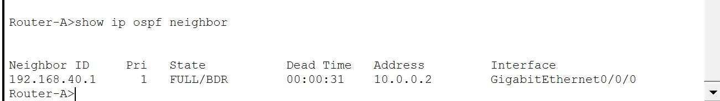
Figure 2: Router-A — Neighbor 192.168.40.1, State: FULL/BDR, Address: 10.0.0.2
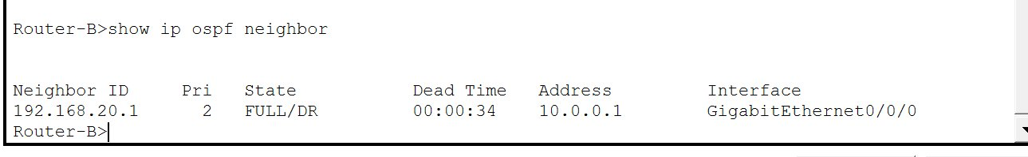
Figure 3: Router-B — Neighbor 192.168.20.1, State: FULL/DR, Address: 10.0.0.1
Ping Test — Building A to Building B (Cross-Building)
ping 192.168.30.20 was run from PC-Student-A1 to PC-Student-B1. 75% success — first packet timed out due to ARP resolution (normal behaviour). Remaining 3 packets received replies confirming cross-building connectivity.

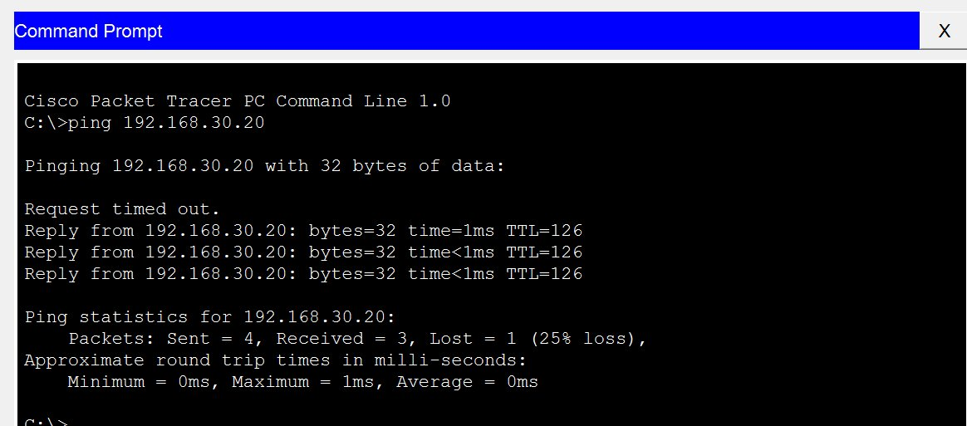
Figure 4: ping 192.168.30.20 — Building A to Building B (75%, ARP first packet normal)
Ping Test — Inter-VLAN (Students to Staff, same building)
ping 192.168.20.21 was run from PC-Student-A1 (VLAN 10) to PC-Staff-A1 (VLAN 20). 100% success with 0% packet loss confirming inter-VLAN routing via Router-A sub-interfaces.

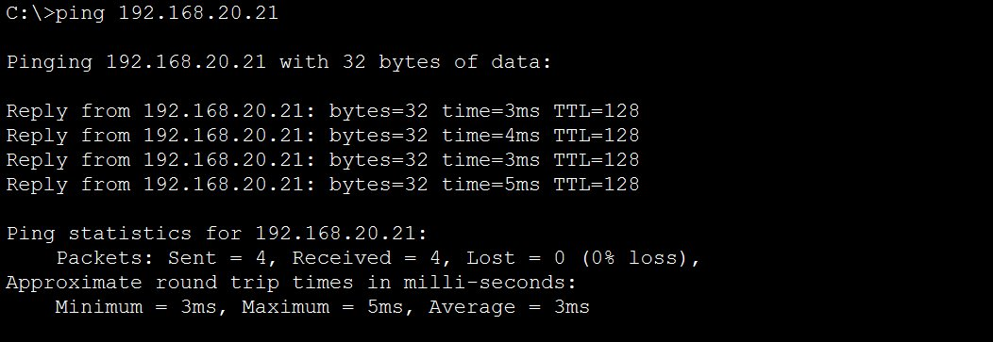
Figure 5: ping 192.168.20.21 — Inter-VLAN Students to Staff (100% success, 0% loss)
Traceroute — 3-Hop Path Verification
tracert 192.168.30.20 was run from PC-Student-A1 to confirm the path packets take. Output shows 3 hops: Router-A (192.168.10.1), Router-B WAN (10.0.0.2), and destination PC (192.168.30.20).

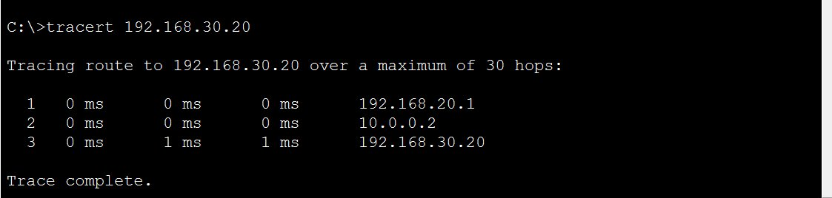
Figure 6: tracert 192.168.30.20 — 3-hop path: Router-A to Router-B to Destination
DNS Verification — nslookup campus.local
nslookup campus.local was run from PC-Student-A1. DNS server at 192.168.10.10 correctly resolved campus.local to 192.168.10.10 confirming DNS is operational.

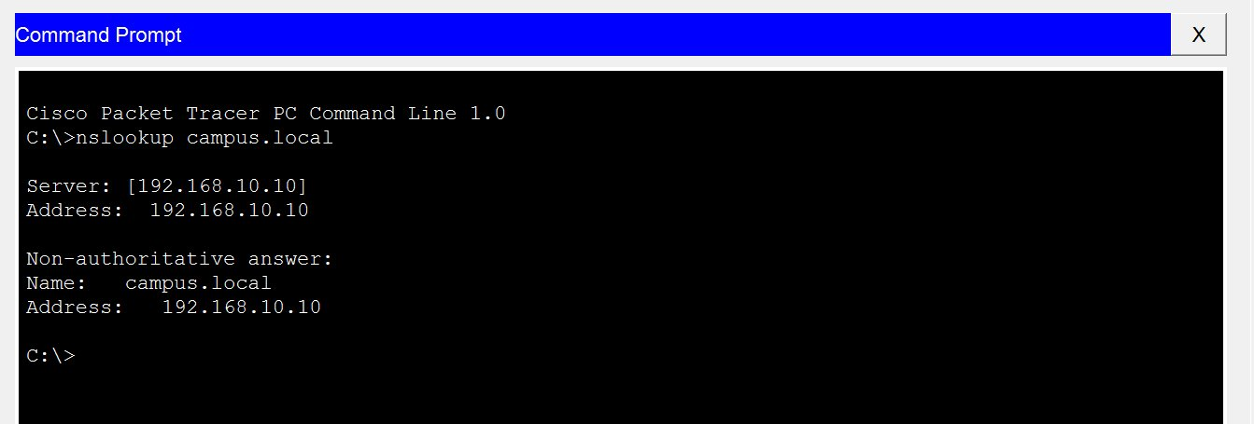
Figure 7: nslookup campus.local — resolved to 192.168.10.10 by DNS server
DNS Ping — ping campus.local
ping campus.local was executed to confirm end-to-end DNS resolution. The PC resolved the name to 192.168.10.10 and received 4/4 replies with 0% packet loss.

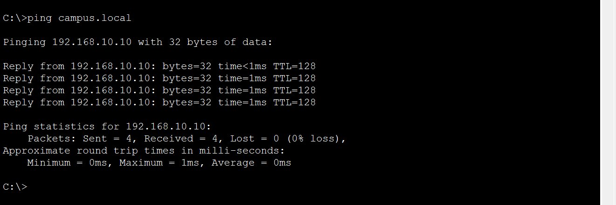
Figure 8: ping campus.local — DNS resolved and 100% ping success
DNS Ping — ping buildingB.local (Cross-Building DNS)
ping buildingB.local verified that DNS resolution works across buildings. The name resolved to 192.168.30.1 and all 4 packets received replies.

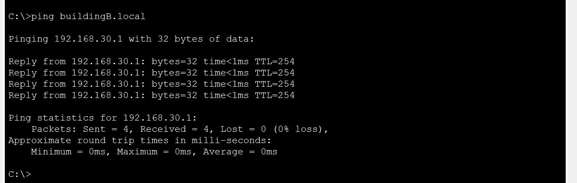
Figure 9: ping buildingB.local — resolved to 192.168.30.1, 100% success
Discussion and Conclusion
In this project, a fully functional campus network was successfully designed and implemented in Cisco Packet Tracer. The network comprised two buildings, each with dedicated VLANs separating student and staff traffic. The Router-on-a-Stick technique was applied on both routers to enable inter-VLAN routing using 802.1Q sub-interfaces. OSPF dynamic routing was configured between the two routers, which successfully achieved a FULL neighbour state and automatically propagated all four VLAN subnets across buildings without any static routes. DHCP servers were configured with ip helper-address to distribute IP configuration across VLAN boundaries, and all six PCs received correct addresses automatically. DNS A records were added so devices could be reached by name rather than by IP.

All tests passed successfully — ping between buildings confirmed cross-building connectivity, inter-VLAN ping confirmed routing between student and staff networks, traceroute showed the expected 3-hop path through both routers, and DNS resolution worked correctly for both local and cross-building domain names. Minor observations such as the first ping packet timing out due to ARP resolution and the OSPF neighbour initially showing 2WAY/DROTHER state before converging to FULL were expected behaviours resolved through correct priority configuration.

Hence the project was completed with a proper knowledge and implementation of Campus Network Design using VLANs, OSPF, DHCP, DNS, and Subnetting using Cisco Packet Tracer.

